SUB QUERY:
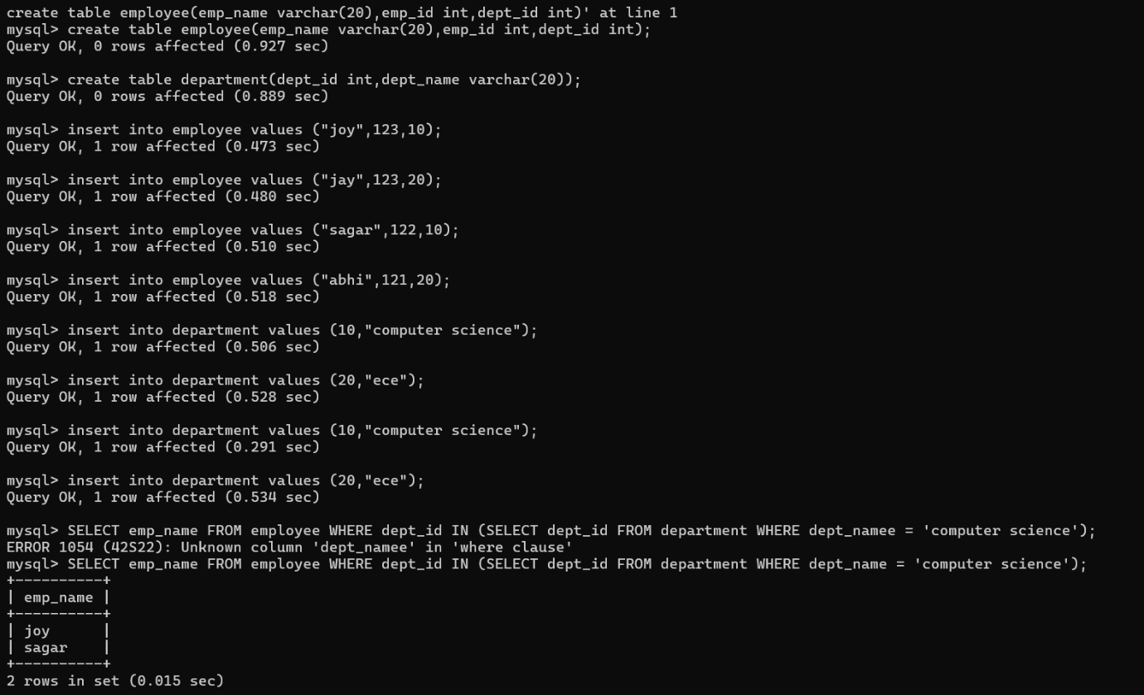
CORRELATED SUBQUERY:
